# <https://judge.softuni.bg/Contests/Practice/Index/1858#0>

# The Garden

Create a program that helps you **harvest** vegetables. There are **three** kinds of **vegetables** in your garden:

* **Lettuce** – **'L', Potatoes** – **'P', Carrots**  – **'C'**

**First**, you will receive the **rows** of the garden. Then for **each** row, you will receive the **vegetables**, separated by space in the following format:

**"{vegetable1} {vegetable2} {vegetable3}… {vegetablen}"**

Then you will start receiving **commands**. Here are the possible ones you can receive:

* **"Harvest {row} {col}"** – you must go to the given place in the garden and harvest the vegetable, **if it exists**. When you harvest a vegetable, you leave an **empty** **space** in the cell – **' '.** Keep in mind, that you **can't harvest** a vegetable, which was already **harvested** or **harmed**.
* **"Mole {row} {col} {direction}"** – there is a mole in that cell and it goes in that direction, which means the mole, goes from **this** **cell** until the last cell in the given direction. It **harms** the **given cell**, **skips the next**, and **harms** **the next one**, an so on **until the last cell**. **Mark** the **harmed** cells with a **space** - **' '**. Keep in mind, that you **can't harm** a vegetable, that was **already harmed** or **harvested**. There are four possible directions:
  + **"Up", "Down", "Left", "Right"**
* **"End of Harvest"** – ends the input.

Here is an example of the **mole's harm radius**:

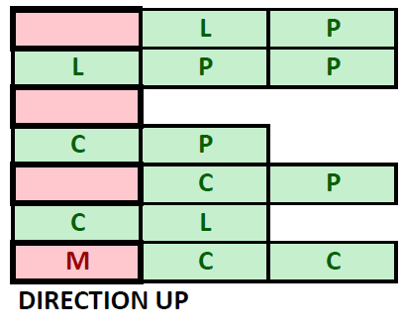

In the end, **print the resulting garden**. The cells must be **separated by a space**. Then **print** the **vegetbles** you have succesfully **harvested** and the **count** of **harmed** **vegetables** you have found in the following format:

**"Carrots: {countOfCarrots}**

**Potatos: {countOfPotatos}**

**Lettuce: {countOfCucmbers}**

**Harmed vegetables: {count}"**

### Input / Constraints

* On the first line, you will receive the **count** of **rows**.
* On the next lines, for **each** **row**, you will receive the vegetables in the described format.
* Next, until you receive **"End of Harvest"**, you will be receiving commands in the described format.
* The input will always be **valid** and you don't need to check it explicitly.

### Output

* Print the **resulting** **garden** – each cell separated by a single space.
* Print the **harvested** and **harmed** **vegatables** in the format described above.

### Examples

|  |  |  |
| --- | --- | --- |
| ****Input**** | ****Output**** | ****Comment**** |
| **4**  **L P C L L**  **L L C P P P**  **C C C C**  **P C L P C L P C L**  **Harvest 0 2**  **Harvest 3 0**  **Harvest 4 2**  **Mole 2 2 up**  **Mole 1 1 right**  **End of Harvest** | **L P L L**  **L C P**  **C C C**  **C L P C L P C L**  **Carrots: 1**  **Potatoes: 1**  **Lettuce: 0**  **Harmed vegetables: 4** | When we receive the "**Harvest**" command, we go to the **given** **coordinates** and harvest the **'C'** and leave an empty space **' '**. After that, we go to the **'P'** on 3 0 and we take it. After that we receive **invalid** **coordinates**, so we don't do anything. Upon receiving the **mole** command, we **harm** the vegetable in **its cell** and every vegetable in the described way – harm the current cell, **skip** the **next** and this repeats **until the end of the row/coll.** We leave **empty** **spaces** in the cells. In the end, we have **4** **harmed** **vegetables**, **one** harvested **carrot** and **one** harvested **potato**. |
| **3**  **P L C**  **C C C C C C**  **L L P P P L L L**  **Harvest 0 0**  **Harvest 1 3**  **Mole 2 0 up**  **Harvest 2 5**  **Harvest 1 1**  **Harvest 0 2**  **Harvest 1 4**  **End of Harvest** | **L**  **C C C**  **L P P P L L**  **Carrots: 4**  **Potatoes: 1**  **Lettuce: 1**  **Harmed vegetables: 1** |  |